**DAILY ONLINE ACTIVITIES SUMMARY**

|  |  |  |  |  |  |  |  |  |
| --- | --- | --- | --- | --- | --- | --- | --- | --- |
| **Date:** | **06-6-2020** | | | | | **Name:** | **Likhitha.M** | |
| **Sem & Sec** | **6th sem ‘A’** | | | | | **USN:** | **4al17cs046** | |
| **Online Test Summary** | | | | | | | | |
| **Subject** | | **Python Application Program** | | | | | | |
| **Max. Marks** | | **30** | | **Score** | | | **25** | |
| **Certification Course Summary** | | | | | | | | |
| **Course** | **Cloud Foundations** | | | | | | | |
| **Certificate Provider** | | | **Great learning** | | **Duration** | | | **3 days** |
| **Coding Challenges** | | | | | | | | |
| **Problem Statement:**  1.Write a program in C to rotate an array by N positions.  **Expected Output :** **The given array is :** 0 3 6 9 12 14 18 20 22 25 27 Enter the Position N from where you want to rotate: 4 From 4th position the values of the array are : 12 14 18 20 22 25 27 Before 4th position the values of the array are : 0 3 6 9 After rotating from 4th position the array is: 12 14 18 20 22 25 27 0 3 6 9  **2.**Write a Python program to perform Cyclic Redundancy Check  CRC uses Generator Polynomial which is available on both sender and receiver side. An example generator polynomial is of the form like x3 + x + 1. This generator polynomial represents key 1011. Another example is x2 + 1 that represents key 101. Data word to be sent - 100100 Key - 1101 [ Or generator polynomial x3 + x2 + 1]  **3.** Description: Write a Python program to count the number of strings, provided string length is 2 or more and the first and last character are same from a given list of strings. Eg: Input list1['hia', 'aba' , '363'] Output: Number of strings with first and last cahracter is same: 2 | | | | | | | | |
| **Status: completed** | | | | | | | | |
| **Uploaded the report in Github** | | | | | **yes** | | | |
| **If yes Repository name** | | | | | **https://github.com/likhithaMantaral/Daily-status** | | | |
| **Uploaded the report in slack** | | | | | **yes** | | | |

Online test Details:

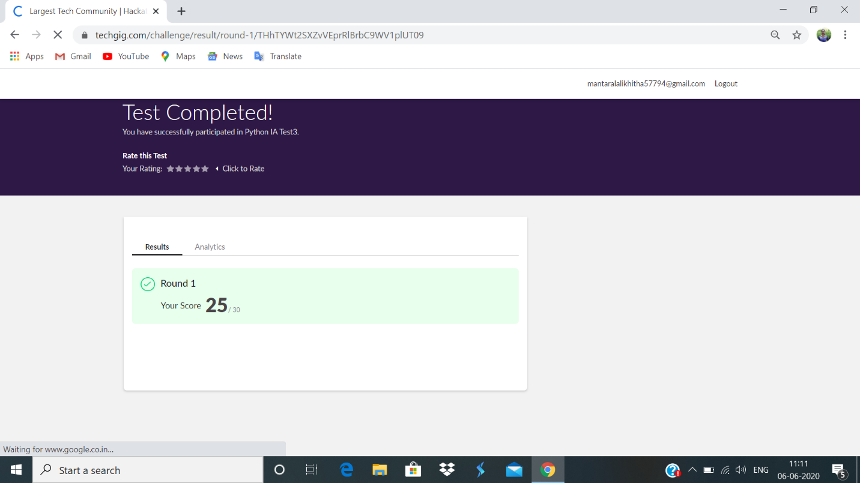

Certification Course Details:

**Successfully completed course- Cloud Foundations**

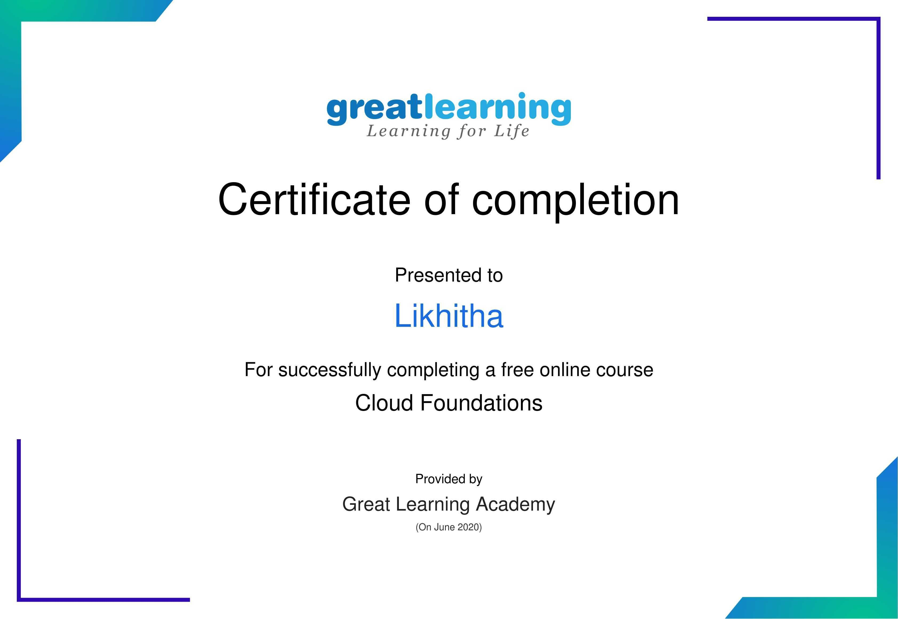

**Coding challenge:**

**1.**

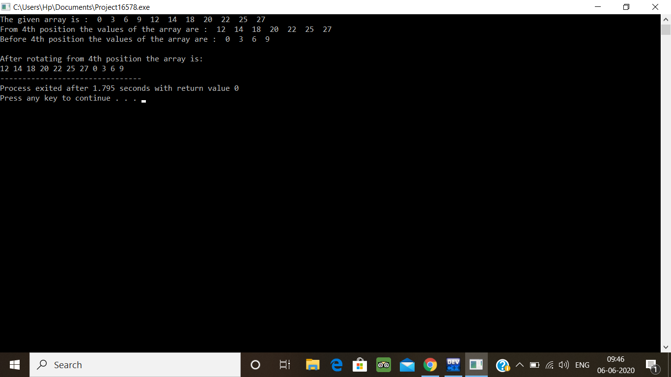

2.

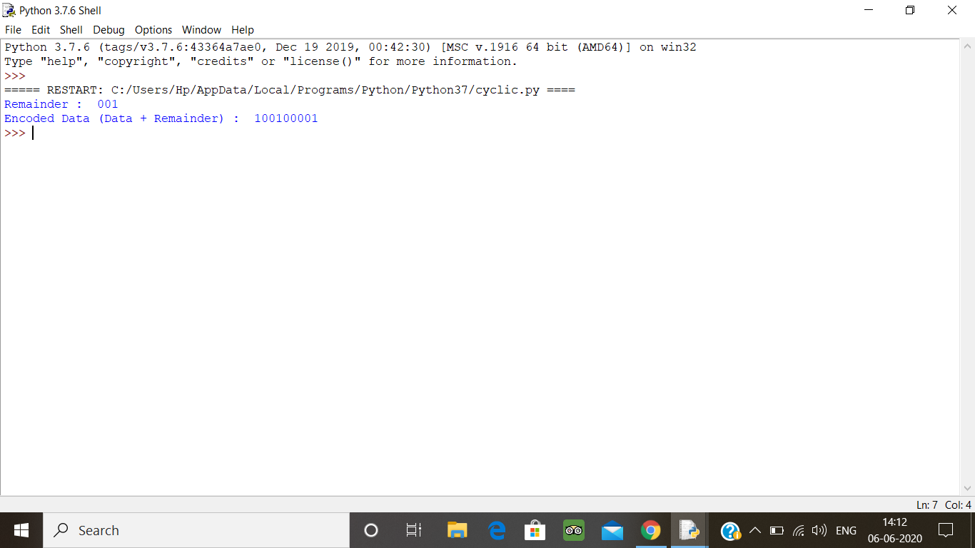

3.

